

**CS 319 - Object-Oriented Software Engineering**

**Final Report**

***GENIUS***

|  |  |
| --- | --- |
| Group15 |  |
| Asena Rana Yozgatlı | *21000132* |
| Serhan Gürsoy | *21400840* |
| Kutbidin Ululu Meder | *21303000* |
| Mustafa Said Sarı | *21302224* |

**Deadline: 24/12/2016**

*Course Instructor: Bora Güngören*

# Changes of the Design

There is no major change on the design of the Genius application. Design is done using MVC architectural style as stated in the previous report. So there are view, controller and model parts of the implementation which are forming packages. The architectural style is strictly followed in order to make the application clear for maintenance reasons. The design changes are not many between the initially proposed design and the design during the implementation. So, some classes and methods are removed and some new methods are added. So the changes are as follows:

**View:**

In View package, the major changes are done *OptionLayer* class. Additionally, the relationship between the classes in this package also changed.

**Model:**

In a new design, there is no *Killer* and *GoogleSearch* classes, others are same.

**Controller:**

The new controller *Responder and Dispatcher* classes have more methods in this new version. Also, the new *enums* are added.

The final design looks like as follows when Model, View and Controller packages are in together.

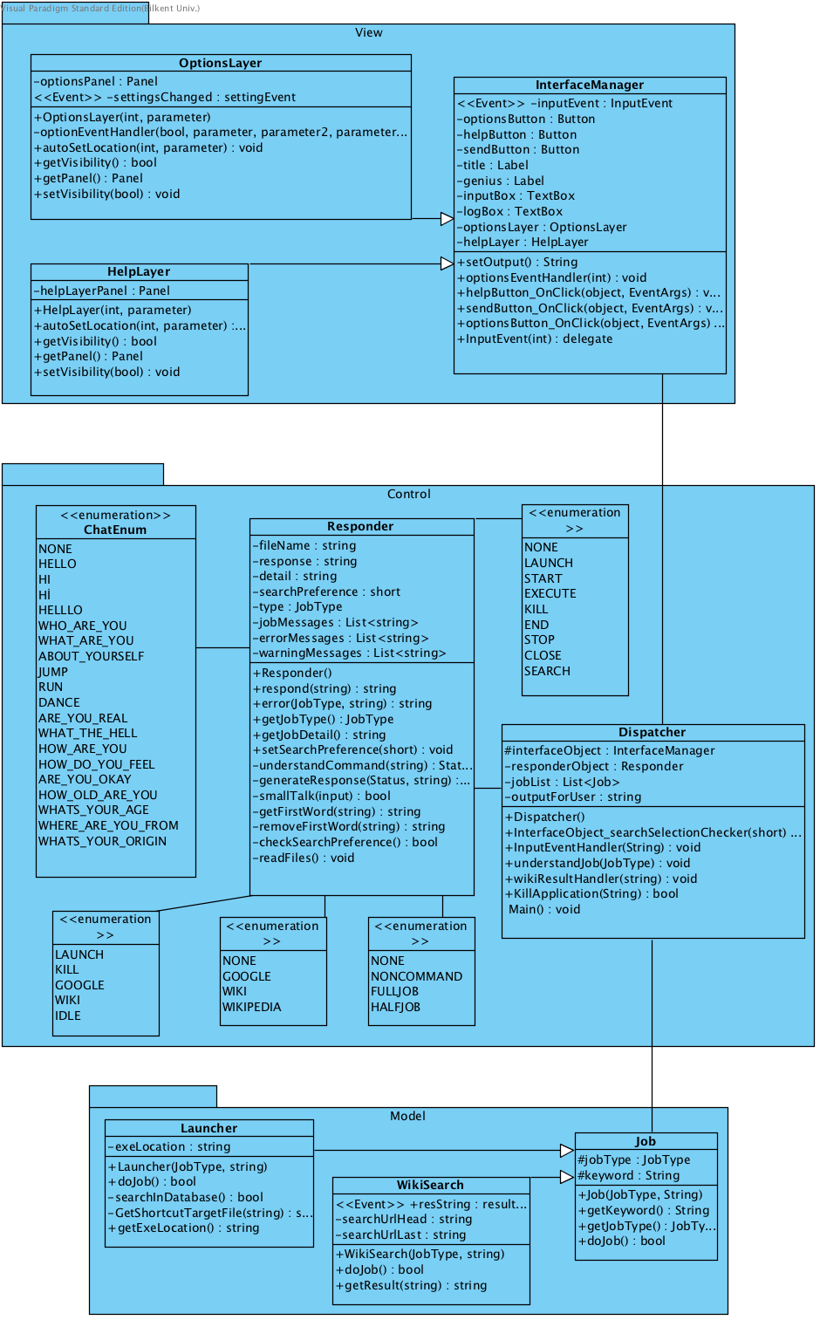

Fig-1 Genius MVC